APRIL 2018

Intention from the Pope’s Worldwide Prayer Network

Universal: For Those who have Responsibility in Economic Matters
That economists may have the courage to reject any economy of exclusion and know how to open new paths.

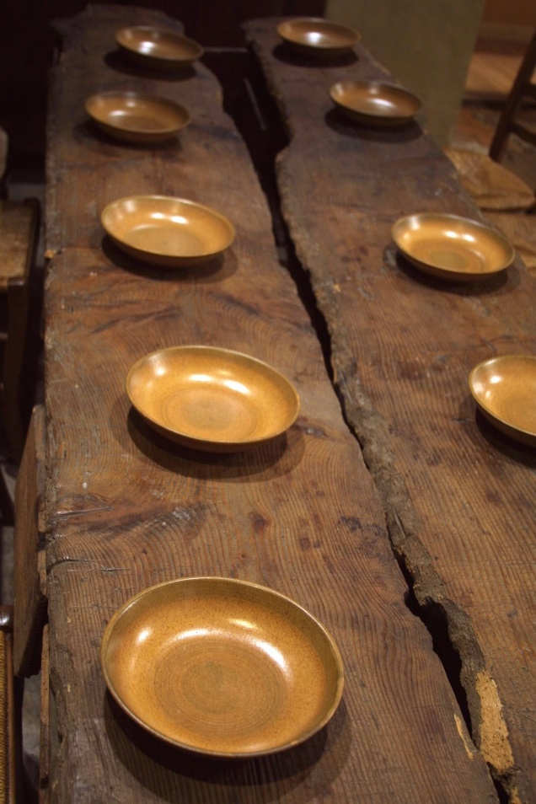

The reflections this month are drawn from the Constitutions.
Sunday 1 | Easter Sunday

Readings: Acts 10:34a,37-43; Col 3:1-4 (1Cor 5:6b-8);
Jn 20:1-9 (Mk 16:1-7)
Intention 1: That we come to know the Risen Lord.
Intention 2: The Brothers’ Community and Marists, Marcellin College, Randwick, NSW.
Reflection: Jesus is the perfect example that we try to follow. Prompted by the Holy Spirit, we seek to carry out the Father's will in all things, and, in this way, to enter into the Pascal Mystery of the Son. (C.36)

Monday 2 | Easter Monday

Readings: Acts 2:14,22-33; Mt 28:8-15
Intention 1: For the unity of the Institute.
Intention 2: The Brothers’ Community and Marists, Marist College, Ashgrove, QLD.
Reflection: In whatever he undertook, Father Champagnat was primarily concerned to do God's will. This he sought in prayer, in consultation, in the mediation of his superiors, and in heeding the signs of the times. (C.39)

Tuesday 3 | Easter Tuesday

Readings: Acts 2:36-41; Jn 20:11-18
Intention 1: For the young men across the region who are initial formation.
Intention 2: The Brothers’ Community and Marists, Marist College, Bendigo, VIC.
Reflection: Two important helps in coming to see things as the Father sees them are spiritual discernment and sincere, frank dialogue with the Superior and with one another. (C.41)

Wednesday 4 | Easter Wednesday

Readings: Acts 3:1-10; Lk 24:13-35
Intention 1: For the young men in formation.
Intention 2: The Brothers’ Community and Marists, Marist College, North Sydney, NSW.
Reflection: Whatever his employment may be, and according to his capabilities, each Brother takes part in community activities, putting his talents at the service of the community and of the apostolic mission. (C.44)

Thursday 5 | Easter Thursday

Readings: Acts 3:11-26; Lk 24:35-48
Intention 1: For those Brothers living outside Marist communities
Intention 2: The Brothers’ Community and Marists, Marist High School, Parramatta, NSW.
Reflection: Our life as consecrated men is a journey in faith, hope, and love. Jesus has challenged each one of us. We have heard His words: "Do not be afraid", and have set aside fears and hesitations in order to follow Him. (C.46)
Friday 6 | Easter Friday

Readings: Acts 4:1-12; Jn 21:1-14
Intention 1: That we heed the calls from God in our lives.
Intention 2: The Brothers’ Community and Marists, Newman College, Churchlands, WA.
Reflection: With Father Champagnat as our guide, we go forward together day after day, hearts filled with gratitude, encouraged by the example of the fidelity of the Brothers who have walked this way before us. (C.46)

Saturday 7 | Easter Saturday

Readings: Acts 4:13-21; Mk 16:9-15
Intention 1: That we live the values we proclaim.
Intention 2: The Brothers’ Community and Marists, Our Lady of the Sacred Heart College, Alice Springs, NT.
Reflection: As we journey on, we may experience doubt, loss of enthusiasm, dryness of heart, or waywardness by pursuing false consolations. We shall fight our way through all this, especially by recourse to Mary, and with the help of our Brothers. (C.46)

Sunday 8 | 2nd Sunday of Easter

Readings: Acts 4:32-35; 1Jn 5:1-6; Jn 20:19-31
Office: Week 2
Intention 1: That we listen attentively to the Word of God in our lives.
Intention 2: The Brothers’ Community and Marists, Paita.
Marist Anniversary: 1872—Opening of the first Marist Brothers school in Australia by Br Ludovic at St Patrick’s, Church Hill.
Reflection: Secure in knowing that God is always faithful, we do not harbour doubts about His call. Thus we come to know the happiness that springs from really living out the total gift of ourselves to God and to others. (C.46)

Monday 9 | Annunciation of the Lord

Readings: Is 7:10-14, 8:10; Heb 10:4-10; Lk 1:26-38
Intention 1: That Mary be the model of our consecrated life.
Intention 2: The Brothers’ Community and Marists, Port Moresby administration.
Reflection: Mary lived out her whole life in the spirit of her "Fiat". By her obedience, she became the Mother of God and co-operated in her Son's redeeming mission. She is blessed because she listened to the word of God and carried it out. (C.38)

Tuesday 10 | Easter Weekday

Readings: Acts 4:32-37; Jn 3:7b-15
Intention 1: For those Brothers living outside Marist Communities.
Intention 2: The Brothers’ Community and Marists, Red Bend College, Forbes, NSW.
Reflection: It is in the love of the Trinity that community life has its origin. The Father wants all people to form one single family in which all will be loved as brothers and sisters. (C.47)

Wednesday 11 | Stanislaus

Readings: Acts 5:17-26; Jn 3:16-21
Intention 1: For those Brothers responsible for the Formation Program.
Intention 2: The Brothers’ Community and Marists, Sacred Heart Colleges, Somerton and Mitchell Parks, SA.
Reflection: Jesus established a community with the apostles and prayed that we might be one, as He and the Father are one. (C.47)

Thursday 12 | Easter Weekday

Readings: Acts 5:27-33; Jn 3:31-36
Intention 1: For those Brothers working in other Administrative Units.
Intention 2: The Brothers’ Community and Marists, St Augustine’s College, Cairns, QLD.
Reflection: We answer the call of Christ by wanting to live together in a community of consecrated persons. (C.47)
Friday 13 | Martin 1

Readings: Acts 5:34-42; Jn 6:1-15
Intention 1: For those Brothers working in other administrative units.
Intention 2: The Brothers’ Community and Marists, St Dominic’s Rural Training Centre, Vanga Point.
Reflection: Our unity shows that God is Love, and that this love, poured into our hearts by the Holy Spirit, is stronger than our human limitations. (C.47)

Saturday 14 | Easter Weekday

Readings: Acts 6:1-7; Jn 6:16-21
Intention 1: For those in initial formation.
Intention 2: The Brothers’ Community and Marists, St Francis Xavier College, Hamilton, NSW.
Reflection: As was the case with the community of the apostles gathered together on Pentecost day, we are conscious of the presence among us of Mary, Mother of the Church. (C.48)

Sunday 15 | 3rd Sunday of Easter

Readings: Acts 3:13-15,17-19; 1Jn 2:1-5a; Lk 24:35-48
Office: Week 3
Intention 1: For those who care for our sick and suffering.
Intention 2: The Brothers’ Community and Marists, St Gregory’s College, Campbelltown, NSW.
Reflection: The Paschal Mystery is not just something that happened many years ago, not just something that we commemorate each ear or that we re-enact each year; it is part of our daily living (Sowers of Hope, p.276).

Monday 16 | Easter Weekday

Readings: Acts 6:8-15; Jn 6:22-29
Intention 1: For those who were Brothers for a time.
Intention 2: The Brothers’ Community and Marists, St Joseph’s College, Hunters Hill, NSW.
Reflection: Mary helps us to live as brothers, bringing home to us the realisation that we make up one body in Christ. (C.48)

Tuesday 17 | Easter Weekday

Readings: Acts 7:51—8:1a; Jn 6:30-35
Intention 1: For those who work for peace and justice.
Intention 2: The Brothers’ Community and Marists, St Joseph’s College, Mabiri, Bougainville.
Marist Anniversary: 1921—Consecration of the Institute to St Joseph.
Reflection: Like Mary at the Visitation and at Cana, we remain attentive to the needs of the community and of the world. Our life, like hers at Nazareth, is to be simple and hard-working. (C.48)

Wednesday 18 | Easter Weekday

Readings: Acts 8:1b-8; Jn 6:35-40
Intention 1: For a deep sense of God’s unconditional love.
Intention 2: Champagnat Marists at the Novitiate, Lomeri.
Marist Anniversary: 1999—Canonisation of St Marcellin Champagnat by John Paull II.
In Memoriam: Br Theophane Durant, 4th Superior General, 1883-1907—the first SG to visit Oceania (Mataro, Spain, 1907).
Reflection: Father Champagnat formed the community of the first Brothers into a real family. He shared their life at La Valla and at the Hermitage, and he spent himself on their behalf. (C.49)

Thursday 19 | Easter Weekday

Readings: Acts 8:26-40; Jn 6:44-51
Intention 1: For those who work in solidarity with us.
Intention 2: The Brothers’ Community and Marists, St Joseph’s Primary School, Murgon, QLD.
Reflection: Father Champagnat told our first Brothers, "You know that I live only for you, that every day I ask God to give you everything that is genuinely good for you, and that I would give anything, even at the cost of the greatest sacrifices, to procure that for you." (C.49)

Friday 20 | Easter Weekday

Readings: Acts 9:1-20; Jn 6:52-59
Intention 1: For a deeper sense of community.
Intention 2: The Brothers’ Community and Marists, St Joseph’s Secondary School, Laumanasa.
Reflection: Living with Marcellin, living close to our Good Mother, our first Brothers grew steadily in the sense of brotherhood, of devotedness, and of self-renunciation in the service of one another. (C.49)

Saturday 21 | Anselm

Readings: Acts 9:31-42; Jn 6:60-69
Intention 1: For those young men discerning their vocation.
Intention 2: The Brothers’ Community and Marists, St Michael’s Primary School, Daceyville, NSW.
Marist Anniversary: 1951—Br Joche-Albert Ly was shot by the communists at Sichang, China.
Reflection: Faithful to this heritage handed down by generations of Brothers, we live our community life in a great family spirit, thus fulfilling the wish of our Founder: "Love one another as Jesus Christ has loved you.” (C.49)

Sunday 22 | 4th Sunday of Easter

Readings: Acts 4:8-12; 1Jn 3:1-2; Jn 10:11-18
Office: Week 4
Intention 1: For trust and confidence in God.
Intention 2: The Brothers’ Community and Marists, St Thomas More Primary school, Sunshine Beach, QLD.
Reflection: The vows, which are an expression of our love of the Lord, are a unifying force in the Marist community. Chastity, since it frees the heart from a possessive love, opens it to the breadth and dynamism of a love that encompasses everybody. (C.50)

Monday 23 | George, Adalbert

Readings: Acts 11:1-18; Jn 10:1-10
Intention 1: For trust in God.
Intention 2: The Brothers’ Community and Marists, the Hermitage, Mittagong, NSW.
Reflection: The vows, which are an expression of our love of the Lord, are a unifying force in the Marist community. Poverty puts all that we are and everything that we have at the service of others. (C.50)

Tuesday 24 | Fidelis of Sigmaringen

Readings: Acts 11:19-26; Jn 10:22-30
Intention 1: For trust.
Intention 2: The Brothers’ Community and Marists, Trinity Catholic College, Lismore, NSW.
Reflection: The vows, which are an expression of our love of the Lord, are a unifying force in the Marist community. Obedience directs the community to seeking and carrying out the will of God. (C.50)

Wednesday 25 | ANZAC Day

Readings: Wis 1:3-9 (Is 9:1-6); 1Cor 1:18-25 (Eph 2:13-18);
Jn 12:23-28 (Jn 14:23-29)
Intention 1: That we be ready to denounce any abuse of power.
Intention 2: The Brothers’ Community and young Marists at Seabird, Randwick, NSW.
Anniversary: Sunday 25th April 1915—Australian and New Zealand troops landed on the Gallipoli Peninsula.
Reflection: “Those heroes that shed their blood and lost their lives... You are now lying in the soil of a friendly country. Therefore rest in peace. There is no difference between the Johnnies and the Mehmets to us where they lie side by side here in this country of ours... You, the mothers who sent their sons from faraway countries, wipe away your tears; your sons are now lying in our bosom and are in peace. After having lost their lives on this land they have become our sons as well.” (Ataturk)

Thursday 26 | Mark, Evangelist

Readings: 1Pt 5:5b-14; Mk 16:15-20
Intention 1: For young Marists.
Intention 2: The Brothers’ Community at the University College of Aquinas, Adelaide, SA.
Reflection: We accept one another, different in many ways, yet complementary. Each of us should take an interest in the life and work of his Brothers. (C.51)

Friday 27 | Louis Grignion de Montfort

Readings: Acts 13:26-33; Jn 14:1-6
Intention 1: For young men beginning their formation.
Intention 2: The Brothers’ Community, Blacktown, NSW.
Marist Anniversary: 1883—The Institute was consecrated to the Sacred Heart, and was associated with the Apostleship of Prayer.
Reflection: We try to develop a finely-tuned awareness of others—a sensitivity of heart which is quick to see that a companion is troubled, and which finds a tactful way of helping him. (C.51)

Saturday 28 | Peter Chanel SM

Readings: Acts 13:44-52; Jn 14:7-14
or 1Cor 1:18-25; Mk 1:14-20
Intention 1: For young men who are thinking of becoming Brothers.
Intention 2: The Brothers’ Community, Drummoyne, NSW.
Marist Anniversary: 1841—Fr Peter Chanel SM was one of the first Marists to leave France for Oceania in 1836. On 8th November, 1837, together with Br Marie-Nizier Delorme FMS, he started a mission on Futuna Island, where he was martyred this day in 1841.
Reflection: Putting aside our egoism and touchiness, we accept with simplicity a Brother's admonition. We know how to ask pardon and to give it, trying to free our hearts from any resentment. (C.51)

Sunday 29 | 5th Sunday of Easter

Readings: Acts 9:26-31; 1Jn 3:18-24; Jn 15:1-8
Office: Week 1
Intention 1: For young people discerning their vocation in life.
Intention 2: The Brothers’ Community, Heidelberg, Melbourne, VIC.
Anniversary: 1836—Gregory XVI approved the Society of Mary by the Decree Omnium Gentium.
Reflection: Our community becomes a place of friendship, of life shared, where the human qualities and the spiritual gifts of each Brother can flourish. (C.51)

Monday 30 | Pius V

Readings: Acts 14:5-18; Jn 14:21-26
Intention 1: For young people in need.
Intention 2: The Brothers’ Community, Macedon, VIC.
Reflection: By his presence, his care for the Brothers, and his availability, the local superior helps build up a climate of understanding and harmony among them. He gives stimulus to the common effort, co-ordinates it, and provides continuity and cohesion. (C.52)

