

Compassion

The General Chapter invites each Champagnat Marist to a deeper spirituality, one which integrates our lives and is down to earth. Only when we aspect God’s mercy will we be able to be faces and hands of mercy for others.

On the global scale Champagnat Marists have established, or participate in, a number of high profile international projects which seek to be the tender hands and face of God’s mercy for children and young people on the margins. These projects include the:

* Marist District of Asia (Mission Ad Gentes) in Bangladesh, India (West Bengal), Thailand, Vietnam and Cambodia.
* La Valla 200> Champagnat Marist communities in Syracusa (Sicily, Italy), Moinesti (Romania), East Harlem (New York, USA), Tabatinga (Brazil), Atlantis (Cape Town, South Africa), Mount Druitt (Australia), and Cuba.
* South Sudan where two brothers are part of an intercongregational project.
* Fratelli Project in Lebanon where along with the De la Salle Brothers and laypeople from both congregations are involved in a project serving refugees fleeing wars in the Middle East.
* Marist Blues in Aleppo, Syria.

However, each of our Champagnat Marists schools and ministries also seek to be the tender hands and face of God’s mercy in the ordinary day to day interactions in a spirit of simplicity, much like Mary at Nazareth. While they may not get the same level of publicity they as equally important.

Calls - <http://lavalla200.champagnat.org/en/>

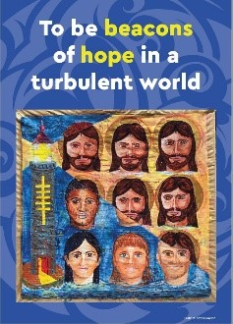 A picture containing text

Description generated with high confidence A picture containing text

Description generated with high confidence A close up of a rug

Description generated with high confidence A close up of a sign

Description generated with high confidence

Lord Jesus,

you call us to discover God’s love

in the ordinary events of life.

You have promised us your Spirit in our lives.

It is this same Spirit that urges us to be prophets of mercy

and of being brothers and sisters to all.

Give us your grace at this time of a new beginning

that we may respond to your call

as Marcellin Champagnat did,

with courage and audacity. Amen.

Mary, our Good Mother, pray for us.

St Marcellin Champagnat, pray for us.

**Champagnat Marist Spirituality and Charism:**

**God’s Presence and Love ✠ Trust in God ✠ Love of Jesus and His Gospel**

**Presence ✠ Simplicity ✠ Family Spirit ✠ Love of Work**

**In the Way of Mary**