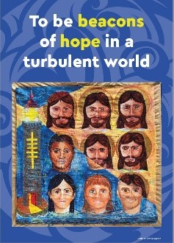

A New La Valla

The Reflections for 2019 are based on the Calls of the XXII General Chapter. The message of the Chapter invites all Champagnat Marists to a new beginning as a global family. Visit the website - http://lavalla200.champagnat.org/en/

The General Chapter called for A New La Valla For A New Beginning. Just as Fr Champagnat gathered the first community at La Valla on 2 January 1817 we are also called to a new beginning. Marcellin was moved by the needs of his time and saw the possibilities around him. He listened attentively to the Spirit, to discover what God was asking of him at the point in time.

In a similar way the General Chapter tried to answer two questions:
- Who is God asking us to be in this emerging world?
- What is God asking us to do in this emerging world?

These two questions are not only addressed to the participants at the Chapter. They are addressed to all Champagnat Marists. The answers to these two questions have been collated and in summary form are presented as the Five Calls of the Chapter Message.

A Prayer of Blessing for the New School Year

May God's Holy Spirit bless us as we begin a new school year.

May the Spirit of the North, the spirit of the Pacific,
surround us with love.
As the sun gives warmth to the earth,
may the Holy Spirit encourage us to share
God’s love with one another.

May the Spirit of the South, the spirit of the Antarctic,
give us courage.
As we brace for cold winds,
may the Holy Spirit give us strength to face
the challenges that we will encounter.

May the Spirit of the East, the spirit of sunrise,
give us wisdom and understanding.
You give us the gift of a new day,
may we never be afraid to start afresh.

May the Spirit of the West, the spirit of sunset,
give us knowledge and good judgement,
may your Word guide the path which we walk.

May the Holy Spirit of God
who is present in this school,
and in each of one of us,
surround us all as we begin
this new school year
with love, joy and peace.
Amen.

Mary, our Good Mother, pray for us.

Champagnat Marist Spirituality and Charism:
God’s Presence and Love Trust in God Love of Jesus and His Gospel
Presence Simplicity Family Spirit Love of Work
In the Way of Mary

