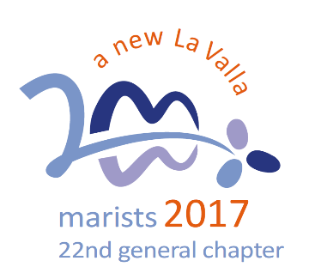
A New Beginning:
Emerging Needs

5. To respond boldly to emerging needs

Jesus, you went through life doing good and yet many of your contemporaries interpreted your actions narrowly, simply because you were a Galilean, a carpenter, and the son of Mary (Mk 6, 2-3).

Today, too, you continue to challenge us to:
- abandon old paradigms and re-imagine ways of helping people see the love of God in today’s world.
- undergo a change of heart and be flexible in our structures, with all the risks entailed, so as to move to the peripheries in defence of the poorest and most vulnerable.
- make a firm commitment to promote and defend the Rights of the Child.
- awaken in ourselves and those around us an ecological awareness that engages us in caring for “our common home”* .

Question:
What could be one goal for us as a school to be agents of change through an education that integrates awakening faith and living by Gospel values?

The Reflections for 2018 are based on the Calls of the XXII General Chapter held in October 2017. http://lavalla200.champagnat.org/en/

Prayer

Lord Jesus,
you went through life doing good
and yet many of your contemporaries interpreted your actions narrowly, simply because you were from Nazareth, a carpenter, and the son of Mary.

Today, too, you continue to challenge us
to abandon old paradigms
and to re-imagine ways of helping people
see the love of God in today’s world.

You call us to undergo a change of heart
and to be flexible in our structures,
with all the risks entailed,
so that we can move to the peripheries in defence
of the poorest and most vulnerable.

May we make a firm commitment to promote
and defend the Rights of the Child.

Awaken in us and those with whom we live and work an ecological awareness that engages us in caring for “our common home”.

Amen.

Mary, our Good Mother, pray for us.

St Marcellin Champagnat, pray for us.

Champagnat Marist Spirituality and Charism:
God’s Presence and Love Trust in God Love of Jesus and His Gospel
Presence Simplicity Family Spirit Love of Work
In the Way of Mary

