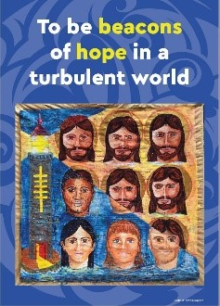

Identity and Action

While the Calls of the General Chapter set a strategic direction for the Institute, they also represent an articulation of our Champagnat Marist story for today. They describe for us how God is working in us today.

Firstly, the Calls challenge us about who we are as Champagnat Marists.
They call us TO BE, but also recognise that we are already on the way:
- To be a global charismatic family
- To be beacons of hope in our turbulent world
- To be the face and hands of God’s tender mercy
- To be bridge builders

Once we have a sense of who we are called to be as Champagnat Marists then we can called TO DO:
- To journey with children
- To respond boldly to emerging needs

Some possible was of being and doing are identified in the Principles and Suggestions. These speak to of us of HOW we are act and organise ourselves.

Calls - http://lavalla200.champagnat.org/en/

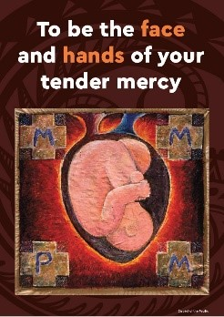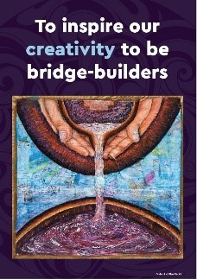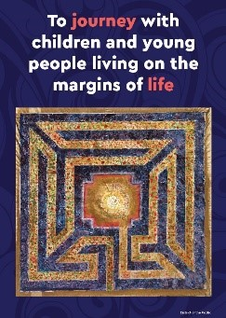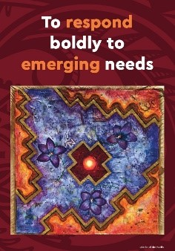

Jesus, the Christ, we rejoice
That you are transforming us
And sending us out as Champagnat Marists on mission.

We rejoice that through your grace
We are a global family,
Beacons of hope in this turbulent world.
You challenge us to be the face and hands of God’s tender mercy.

Inspire our creativity to be bridge-builders,
to journey with children and young people on the margins of life,
and to respond boldly to emerging needs.

You who live with the Father
In the unity of the Holy Spirit
One God, for ever and ever. Amen.

Mary, our Good Mother, pray for us.

St Marcellin Champagnat, pray for us.

Champagnat Marist Spirituality and Charism:
God’s Presence and Love Trust in God Love of Jesus and His Gospel
Presence Simplicity Family Spirit Love of Work
In the Way of Mary

