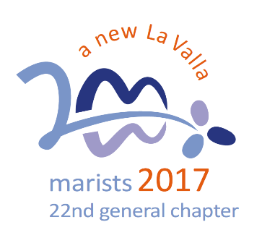
A New Beginning:
A Global Family

- As a global charismatic family, a beacon of hope in this turbulent world

Jesus, today you continue to call us to relate to others in a fundamentally new way (Mark 3, 20-31, 31-35), to listen to your Word and put it into practice, with urgency and without excluding anyone.

You are pressuring us to set out immediately on pathways that lead to the future: that is, as Champagnat Marists to:
- form homes that are a light on the hill for those around, giving ourselves whole-heartedly to creating a family style of life that is open to all.
- promote and nourish Marist life in all its diversity, working towards our deeply-felt desire to act as “one global body”.
- be open, in all simplicity, to make ourselves available to go beyond geographic or provincial boundaries.
- rediscover, as Brothers [and Champagnat Marists], the original passion that inspired us to be Marists.

Question:
What could be one goal for us as a school to be part of the global Champagnat Marist family?

How can we be a beacon of hope in this turbulent world?

The Reflections for 2018 are based on the Calls of the XXII General Chapter held in October 2017. http://lavalla200.champagnat.org/en/

Prayer

Transform us, Jesus, and send us
as a global charismatic family
to be a beacon of hope in this turbulent world.

You continue to call us to relate to others
in a fundamentally new way,
to listen to your Word and put it into practice,
with urgency and without excluding anyone.

At this time of new beginning
we pray for the strength and fortitude
to be faithful to this endeavour.
Amen.

Mary, our Good Mother, pray for us.

St Marcellin Champagnat, pray for us.

Champagnat Marist Spirituality and Charism:
God’s Presence and Love Trust in God Love of Jesus and His Gospel
Presence Simplicity Family Spirit Love of Work
In the Way of Mary

