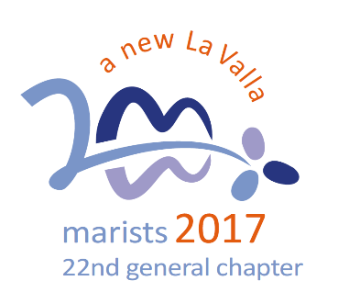
A New Beginning:
Bridge Builders

3. Inspire our creativity to be bridge-builders

Like Mary at Cana (Jn 2, 3), we feel challenged by the needs of the world around us.

Inspired by Mary, we feel called to:
- develop a good understanding of our ever-changing world, and face current challenges, without falling into the temptation of “answering questions that no one is asking anymore”. (Pope Francis in Medellin, September 9, 2017)
- be a prophetic reminder of the common dignity and fundamental equality of the entire People of God.
- move away from a culture shaped by “ego-s” and adopt that of the “eco-s” (ecology, ecosystems, an economy of solidarity, …) to reduce the scandal of indifference and inequality.
- be agents of change, bridge-builders, messengers of peace, transforming the lives of young people through an education that integrates awakening faith and living by Gospel values.

Question:
What could be one goal for us as a school to be agents of change through an education that integrates awakening faith and living by Gospel values?

The Reflections for 2018 are based on the Calls of the XXII General Chapter held in October 2017. http://lavalla200.champagnat.org/en/

Prayer

Lord Jesus,
like Mary at Cana, we feel challenged
by the needs of the world around us.
you call us to be aware of the signs of the times,
to face current challenges,
without falling into the temptation
of “answering questions that no one is asking anymore”.

You call us to be a prophetic reminder of the common dignity
and fundamental equality of the entire People of God.

You call us to move away from a culture shaped by “ego-s”
and to adopt a culture shaped by “eco-s” (ecology, ecosystems, an economy of solidarity, …).

You call us to be agents of change, bridge-builders, messengers of peace, transforming the lives of young people through an education that integrates awakening faith and living by Gospel values.

May we be open to your call at this time.

Amen.

Mary, our Good Mother, pray for us.

St Marcellin Champagnat, pray for us.

Champagnat Marist Spirituality and Charism:
God’s Presence and Love Trust in God Love of Jesus and His Gospel
Presence Simplicity Family Spirit Love of Work
In the Way of Mary

