FORM GOOD CHRISTIANS
AND VIRTUOUS CITIZENS

MESSAGE VII INTERNATIONAL
MISSION COMMISSION
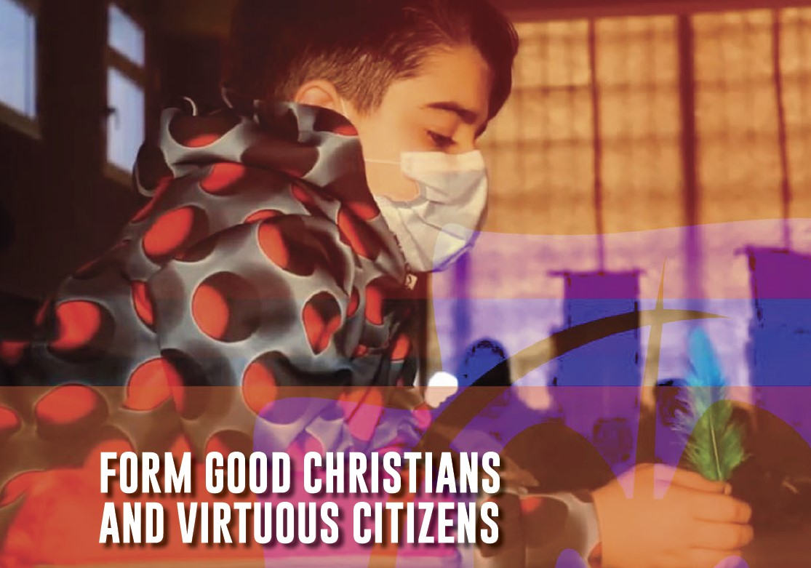

Link to Message VII https://champagnat.org/en/message-of-the-marist-international-mission-commission-form-good-christians-and-virtuous-citizens/

Form Good Christians and Virtuous Citizens – Selected paragraphs
“Form good Christians and virtuous citizens” - a challenge for our time. Marcellin Champagnat invited his first Brothers to form good Christians and virtuous citizens. Today, and more than ever, this invitation still defines our mission as Marist educators, whether we be Brothers or lay people. This two-fold injunction might appear contradictory, if not
impossible to achieve in a globalised world which promotes individualism, rivalry, tribalism, and a culture of waste. Pope Francis urges us to sense “the challenge of finding and sharing a “mystique” of living together, of mingling and encounter, of embracing and supporting one another, of stepping into this flood tide which, while chaotic, can become a genuine experience of fraternity, a caravan of solidarity ...” (Evangelii Gaudium, 87)

Many initiatives already exist throughout the Institute to enable children and young people to experience and engage in volunteering, social commitment and service. International Marist volunteers serve at various levels – local, provincial and institutional – and are appreciated by the institutions with which they work. “Immersion” experiences carried out in our schools and works allow us to develop this sense of global citizenship
and solidarity.

To educate for citizenship and to evangelise mean understanding the complexity of the world, the processes of interdependence and sustainability, and to promote a culture of encounter4 in order to work and build together. It means enabling children and young people to engage with humanity, to develop positive and critical thinking. It means offering ways of participating at all levels: local, national and international, and at the
same time assisting in the discovery of the personal inner life in order to be able to welcome difference.

To educate and evangelise is to form people who see clearly what is happening in society and in the Church and who are in constant search of adequate responses to societal and environmental problems. People capable of recognizing the equal dignity owed to every human being and of defending the fundamental rights which flow from this dignity. People capable of taking care of creation and of our common home.

Prayer

Lord Jesus, like Mary at Cana, we feel challenged
by the needs of the world around us.
You call us to be aware of the signs of the times,
to face current challenges,
without falling into the temptation
of “answering questions that no one is asking anymore”.

You call us to be a prophetic reminder
of the common dignity
and fundamental equality of the entire People of God.

You call us to move away from a culture
shaped by “ego-s”
and to adopt a culture shaped by “eco-s”
(ecology, ecosystems, an economy of solidarity, …).

You continue to call us to be agents of change, bridge-builders,
messengers of peace, transforming the lives of young people through an education which integrates awakening faith
and living by Gospel values. Amen.

Mary, our Good Mother, pray for us.
St Joseph, pray for us.
St Marcellin Champagnat, pray for us.

Champagnat Marist Spirituality and Charism:
God’s Presence and Love Trust in God Love of Jesus and His Gospel
Presence Simplicity Family Spirit Love of Work
In the Way of Mary

