Confidence

In his message for the feast day of St Marcellin, Br Ernesto Sanchez (superior general) highlighted three of Marcellin’s personal qualities. These will form the basis of the reflections for July, August and September.

“During this time, I have often thought of Marcellin. I am not sure if [Marcellin] experienced anything like a world pandemic. Probably not. But I dare say that he must have experienced something similar, or even worse, such as the after effects of the French Revolution or other times of acute difficulty in his own life or in the first years of the Institute. What was it that moved Marcellin to not be paralyzed by fear, or to not remain indifferent in his comfort zone? Among others, I would like to highlight three of his personal qualities: his confidence, his boldness, his brotherhood.

“Confidence. I believe that Marcellin, even in the most difficult times, did not doubt for a moment that his life and his mission were the work of God, the work of Mary. He never held himself up as the lead actor or the one “calling the shots” … rather, he pointed to the Lord, giving praise and glory to God, understanding himself, like Mary, to be the Lord’s servant. He always lived under Mary’s maternal protection and had frequent recourse to her. In moments of crisis, he used to say to her: Mary, this is your work... if it perishes, it is not our work that fails but yours, because you have done everything for us. We count on you, then, with your powerful help; we will always trust in you. (Cf. Life, p. 96).

“His trust in her was not limited to feeling her maternal protection, but it led him to imitate her, to seek to respond to God in Mary’s way. In my greeting of last March 25th, I said: Mary, the one who said ‘yes’, encourages and accompanies us. Like her, in the face of uncertainty and fear, we need faith, trust, and a passion for God and for humanity, as solid bases for moving forward.”

Full text - https://champagnat.org/en/message-of-br-ernesto-sanchez-on-the-occasion-of-the-celebration-of-the-feast-of-st-marcellin-champagnat/

Calls of the General Chapter - http://lavalla200.champagnat.org/en/

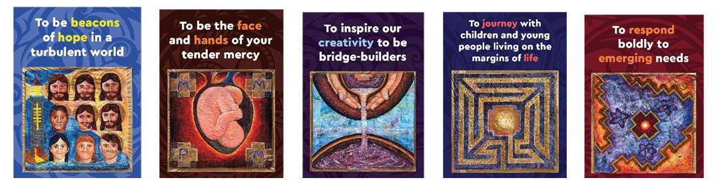
Prayer

God of mystery and new beginnings,
you challenge us to go in haste to a new land.

Like Abraham, our father in faith,
may we journey into the unknown with confidence.

May your Holy Spirit:
Guide our deliberations.
Challenge our thinking.
Renew our vision.

Continue to lead us,
so that we may carry your Word of hope and be
messengers of your love and peace in our places of work,
our homes and our communities.
We make this prayer in the name of Jesus. Amen.

Mary, our Good Mother, pray for us.

St Marcellin Champagnat, pray for us.

Champagnat Marist Spirituality and Charism:
God’s Presence and Love Trust in God Love of Jesus and His Gospel
Presence Simplicity Family Spirit Love of Work
In the Way of Mary

