A New La Valla 3

To be a healing and co-creative presence of our common home

This reflection is based on the remarks by Br Ernesto Sánchez (Superior General) at the closing of the XXII General Chapter, The “New Beginning” Has Already Begun! A copy of the document can be downloaded at: http://www.champagnat.org/lavalla2017.php?a=1a&id=4532

Our common home, our mother earth, has been crying out to us for many years to do something to stop our excessive use and exploitation of our planet. The generosity and abundance of our common home is beginning to wear out, not because it does not want to give us more, but because we are taking excessive advantage of it in uncontrolled ways.

Pope Francis, in his Encyclical Letter Laudato Si‘: On Care for our Common Home, says: “Self-improvement on the part of individuals will not by itself remedy the extremely complex situation facing our world today. Social problems must be addressed by community networks and not simply by the sum of individual good deeds. The ecological conversion needed to bring about lasting change is also a community conversion.” (LS #219)

What positive consequences could be achieved if, we as Champagnat Marists, took joint action, seriously, contributing our small part in the 80 countries where we are present? Could we start from a personal action that progressively affects our schools?

Imagine how this theme of ecology and care of our common home could be incorporated in important decisions regarding the use of resources, and above all in the positive influence we could have on so many people, families, children and young people who, in their daily decisions, are transforming the world.

To do this, we can try to promote a deeper appreciation and respect for ecological concerns, and offer training, through our educational and pastoral ministries.

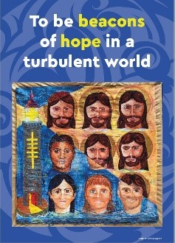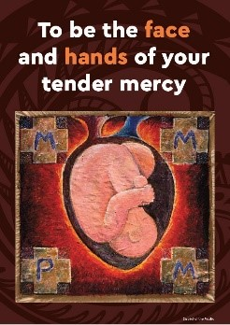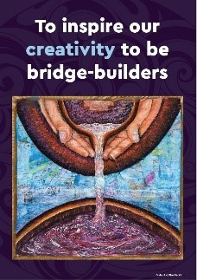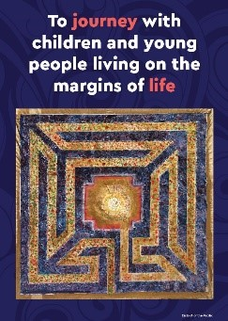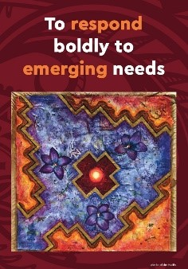

Prayer for our Earth from Laudato Si'

All-powerful God, you are present in the whole universe
and in the smallest of your creatures.
You embrace with your tenderness all that exists.
Pour out upon us the power of your love,
that we may protect life and beauty.
Fill us with peace, that we may live
as brothers and sisters, harming no one.

O God of the poor,
help us to rescue the abandoned and forgotten of this earth,
so precious in your eyes.
Bring healing to our lives,
that we may protect the world and not
that we may sow beauty, not pollution and destruction.

Touch the hearts of those who look only for gain
at the expense of the poor and the earth.
Teach us to discover the worth of each thing,
to be filled with awe and contemplation,
to recognize that we are profoundly united
with every creature as we journey towards your infinite light.

We thank you for being with us each day.
Encourage us, we pray, in our struggle for justice, love and peace.
Amen.

Mary, our Good Mother, pray for us.

St Marcellin Champagnat, pray for us.

Champagnat Marist Spirituality and Charism:
God’s Presence and Love Trust in God Love of Jesus and His Gospel
Presence Simplicity Family Spirit Love of Work
In the Way of Mary

