New Frontiers: Emerging Realities
Message IV International Mission Commission
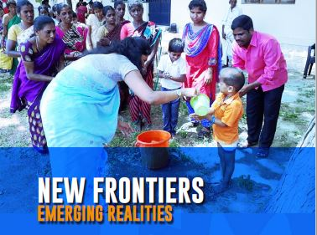

Link to Message IV https://champagnat.org/en/new-frontiers-emerging-realities-message-of-the-marist-international-mission-commission/

New Frontiers: Emerging Realities – Some selected paragraphs

Transforming the lives of children and young people particularly those on the margins is foundational to Marists of Champagnat. It is a fundamental part of our journey. Marcellin’s own experience as a child who missed out on education and his work as a
curate in the parish of La Valla provoked in him a deep empathy for children and young people unable to fulfil their potential. La Valla was an isolated village where children had limited access to education, and this meant these children lived on the margins of French society. Marcellin founded the Brothers as a response to his experience of young people
living on the margins. Throughout his life, he continued to express this desire to move to the peripheries by his personal longing to head out to the mission fields of America (1820’s) and the Pacific (1830’s). Marcellin’s original intuition has developed into an Institute with a fine tradition of moving to the margins in response to the needs of children and young people.

The Marist response is to reflect, to empathize with the young, to dialogue with them and to act where we can. This is part of what it means to be Marist. The recent General Chapter calls us to journey with and be present among children and young people living on the margins of life. It also calls us to open our eyes and hearts, move out of our comfort zone, and hear the cries of those who are voiceless and marginalized being creative in
responding to their needs and empowering those without a voice.

Marists of Champagnat have a deep-rooted awareness of the situation of children and young people living on the peripheries and a clear commitment to be present among them. There is a growing inequality in education, and many are denied access to quality
and appropriate education. This is more than a reaction to geographic isolation and a traditional “missionary” response. The Institute continues to explore new ways to be present among those young people on the margins of life. Through projects such as La Valla 200, Fratelli, South Sudan and its continued support of the Marist District of Asia, the General Administration gives visibility in different ways to working with vulnerable children, adolescents and young people. These projects make evident the new frontiers and margins towards which we are moving.

Prayer

Loving God, You inspired Marcellin to meet the educational
and spiritual needs of children and young people
in their rural isolation.

You inspire us today to meet
the educational and spiritual needs
of the students committed to our care.
Give us the same audacity and vision
that you gave Marcellin.

Mary our Good Mother and Ordinary Resource,
if this work of education should fail,
it is not our work which fails, but yours,
for you have done everything for us.

Bless us Good Mother,
bless this school and all who work, study and dream here. Amen.

Mary, our Good Mother, pray for us.
St Joseph, pray for us.
St Marcellin Champagnat, pray for us.

Champagnat Marist Spirituality and Charism:
God’s Presence and Love Trust in God Love of Jesus and His Gospel
Presence Simplicity Family Spirit Love of Work
In the Way of Mary

