A New La Valla 2

Probably the most dominant symbol at La Valla is the table. This, like much of the furniture, was built by Marcellin when the first community was formed on 2 January 1817.

Br Ernesto Sánchez (Superior General) commented in his message at the close of the XXII General Chapter, that the table “is a clear and powerful symbol for all those who today are deeply connected with Marcellin’s charism. There is room for all at this table: Brothers, Marist lay men and women, many educators, those people serving in Marist works, children, youth, former students, families, together with some priests, and men and women religious who nourish their vocational path from Marist sources.

“It is a table that welcomes all the Marists of Champagnat. A table to which all can approach. This is the greatness of this gift to the Church and to the world; the Marist charism which makes us feel like we all belong to a great family.

“The table that Champagnat built balances on four legs, which could be likened to the four key columns of our ‘New Beginning’:

1. To be tireless searchers for meaning in our search for God;
2. To form homes that nurture life and generate new life;
3. To be prophets of human dignity, present among the most vulnerable and
children and youth, who have no voice.
4. To be a healing and co-creative presence of our common home.

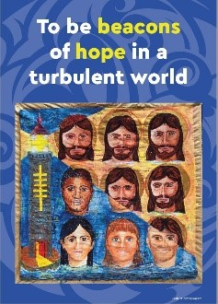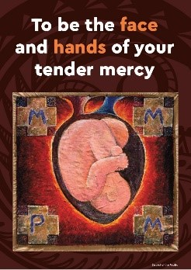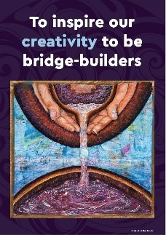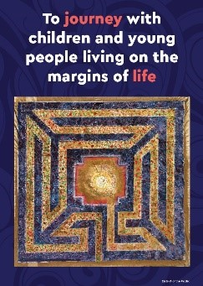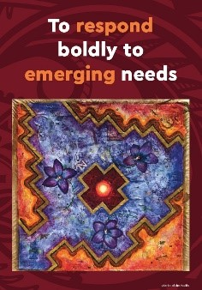

Prayer

Loving God
your call is unique to each of us,
a mystery that surprises us
and invites us with equal dignity
to live Champagnat’s charism alongside our brothers and sisters.
As we deepen our unique call
to be disciples of Jesus like Mary,
keep us mindful of the Spirit’s energy
within our hearts and in our day-to-day events.
Guide us, be with us and lead us with Mary,
on the path of true discipleship.
In Christ our brother we ask this. Amen.

Mary, our Good Mother, pray for us.

St Marcellin Champagnat, pray for us.

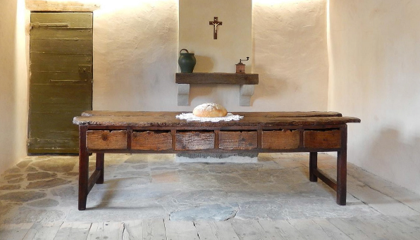

Champagnat Marist Spirituality and Charism:
God’s Presence and Love Trust in God Love of Jesus and His Gospel
Presence Simplicity Family Spirit Love of Work
In the Way of Mary

