Homes of Light 4
Caring for Life
Generating New Life

Mary, transparent to the Light – 3 of 3
Of all the phrases in the Gospels where direct mention is made of Mary, there is one in particular that attracts my attention, “Mary treasured all these things and pondered over them in her heart” (Lk 2:19). The heart is mentioned often in the Bible as the inner place within humans, the seat of ideas, feelings and memories … but, especially, where divine Being can be perceived and sensed, since this is the mystery of the incarnation. To treasure, meditate, ponder in our hearts is to read, understand, and accept our lives and events as God sees them. It is to listen to the inner voice whispered to us by the Spirit, inspiring the best steps to take.

A heart that listens, meditates, ponders and discerns is the ideal place for radiating light and, consequently, for letting God’s light shine through us. Such a heart has the capacity to reduce the force of our ego because it makes greater room for the presence of God. This is how I imagine Mary in her daily life, a woman with a peaceful heart, busy about her household tasks, treating people sensitively, and ready to help out when needed. I imagine her, together with Joseph and Jesus, creating a home, a home of light. I also imagine her being alert to signs of relational difficulties, resolving any possible tensions that cropped up from time to time in their own family or between their neighbours. Her kind face, her smile, her attitudes, her words and her patience all made visible the light coming from within that was constantly replenishing her: the very light of God that gives birth to dedication, service, selflessness, kindness and peace.

After contemplating Mary, let us explore our own hearts. Am I thirsty and longing for God? Deep down, is my heart in tune with the presence of God dwelling in me? Do I really want to be free of all the attachments that are paralysing me, that stop me from getting ahead and that prevent me from being open to newness and change? Do I have a heart that is open to the needs of others and ready to serve without counting the cost?

The questions for us today are:
“Who is God calling us to be?” and “What is God calling us to do?”

The reflection from Homes of Light, Br Ernesto Sánchez Barba (Superior General).
https://champagnat.org/en/circulares/homes-of-light-caring-for-life-generating-new-life/

Prayer

Loving God
your call is unique to each of us,
a mystery that surprises us
and invites us with equal dignity
to live Champagnat’s charism alongside our brothers and sisters.
As we deepen our unique call
to be disciples of Jesus like Mary,
keep us mindful of the Spirit’s energy
within our hearts and in our day-to-day events.
Guide us, be with us and lead us with Mary,
on the path of true discipleship.
In Christ our brother we ask this. Amen.

Mary, our Good Mother, pray for us.
St Joseph, pray for us.
St Marcellin Champagnat, pray for us.

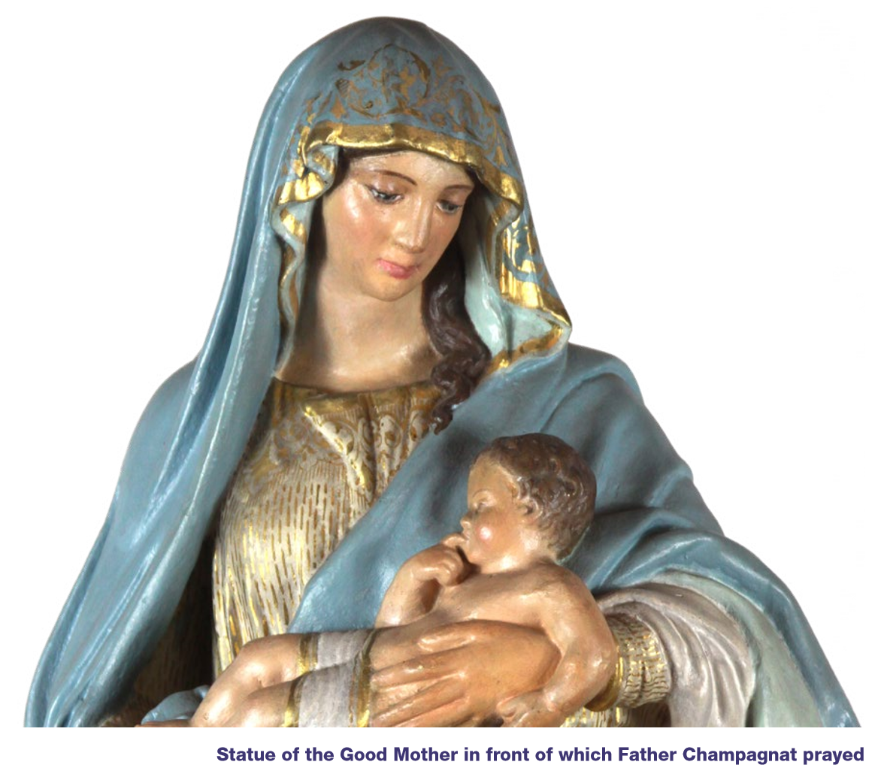

Champagnat Marist Spirituality and Charism:
God’s Presence and Love Trust in God Love of Jesus and His Gospel
Presence Simplicity Family Spirit Love of Work
In the Way of Mary

