Defenders of Rights and Committed to the Culture of Protection of Children in all Marist Missions

Message X International Mission Commission
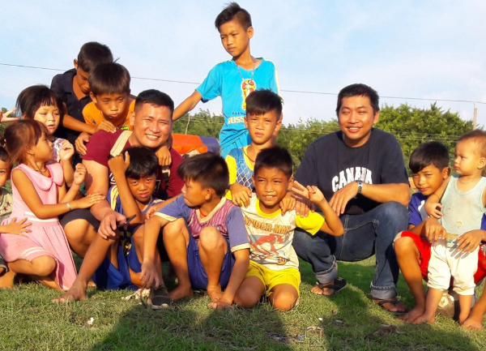

Link to Message X

Defenders of Rights and Committed to the Culture of Protection of Children in all Marist Missions – Selected paragraphs

The Marist background and its relationship with the promotion, guarantee and defence of the rights of children can be traced back to the influence of the social and political context in which Father Marcellin Champagnat was born: 1789, the effervescence of the French Revolution and the same year in which the Declaration of the Rights of Man and of the Citizen was approved, a universal event, since it constituted the basis for the Declaration of the United Nations in 1948. At the family level, his father, politically committed, inherited Marcellin’s taste for action, his sense of responsibility, and his openness to innovative ideas; his mother and an exclaustrated aunt awakened in him a strong faith and a deep devotion to Mary.

His audacity and perseverance to achieve his objective in favour of the most humble children and young people in his context and in his time, those who lived in the countryside, can be translated today as a clear and decisive response against the violation of the right to education. A response with a distinctive stamp: an education mediated by love and not by violence - “To educate children you must love them” - and which forms good Christians and virtuous citizens. The issue of protection from sexual abuse was also addressed by Marcellin.

Today, as then, there are many realities that children, adolescents and young people face and that put at risk the guarantee of their rights, especially those who live in situations of greater vulnerability, accentuated at this historic moment by the pandemic: invisibility, insufficient health services, forced mobility, exposure to multiple forms of violence, economic deprivation and unemployment in families, lack of access to education, physical and psychological abuse, sexual violence, discrimination, etc. Faced with these problems, the Marists of Champagnat, brothers and lay men and women, make the calls of the XXII General Chapter our own and we are taking steps to make them a reality: “The Institute promotes, protects and defends the rights of children and young people and their empowerment as agents of transformation.”

Prayer

Lord Jesus,
you continue to call us to discover God’s love
in the ordinary events of life.
You have promised us your Spirit in our lives.
It is this same Spirit which urges us to be prophets of mercy
and of being brothers and sisters to all.

Give us your grace at this time of a new beginning
that we may respond to your call
as Marcellin Champagnat did,
with courage and audacity.

Conscious that our work is in the hands of Mary,
our Good Mother,
may we continue to build homes of light
which care for life and generate new life. Amen.

Mary, our Good Mother, pray for us.
St Joseph, pray for us.
St Marcellin Champagnat, pray for us.

Champagnat Marist Spirituality and Charism:
God’s Presence and Love Trust in God Love of Jesus and His Gospel
Presence Simplicity Family Spirit Love of Work
In the Way of Mary

